**TASK-07**

Shipping Charges

**EXPLANATION:**

The program asks the user to enter his / her luggage weight and also the distance the luggage has to be carried. If the weight of luggage is less than or equal to zero, the program gives an error that the weight is not in the weight limit also if user enters the distance less than 10 Km or greater than 3000 Km, the program gives an error and asks the user again to enter the distance again. If everything is correct then the program calculates the charges for the user and displays as output.

**INPUT:**

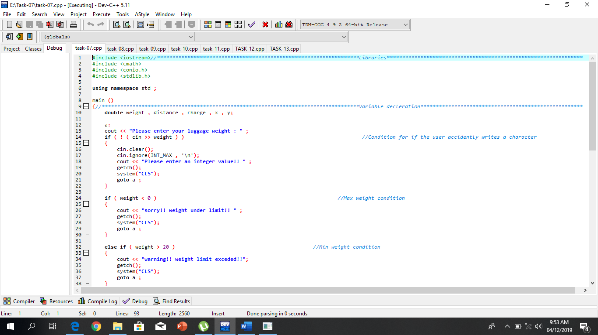

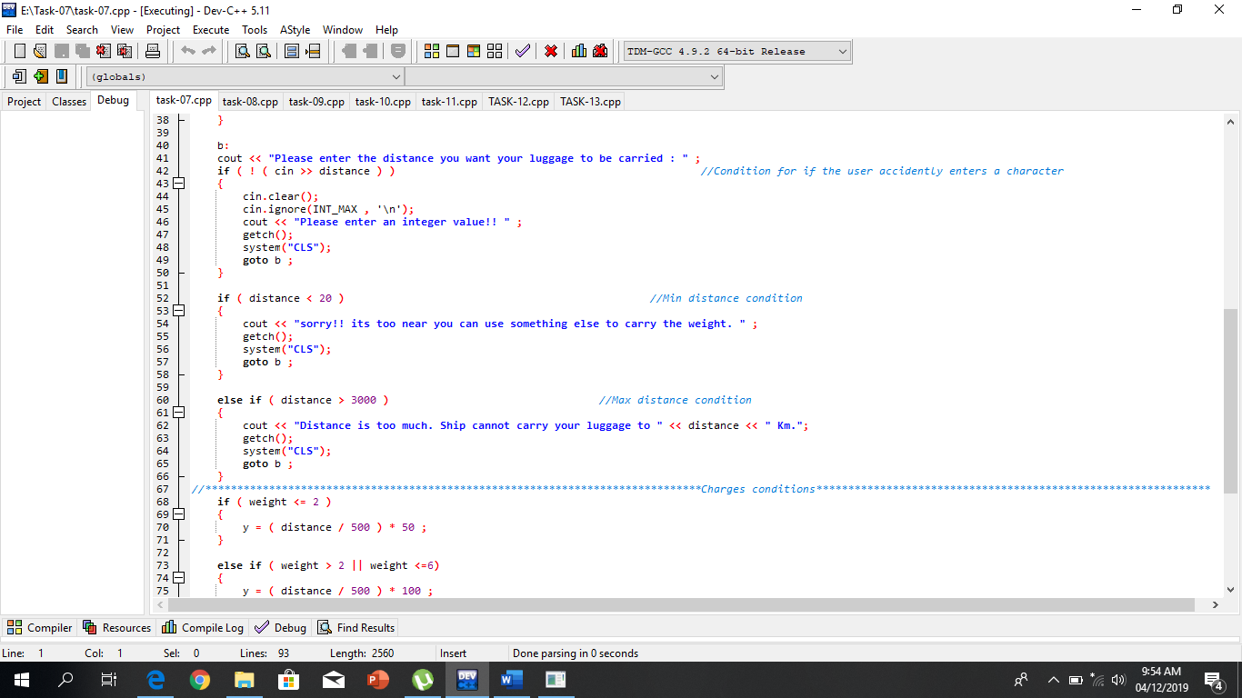

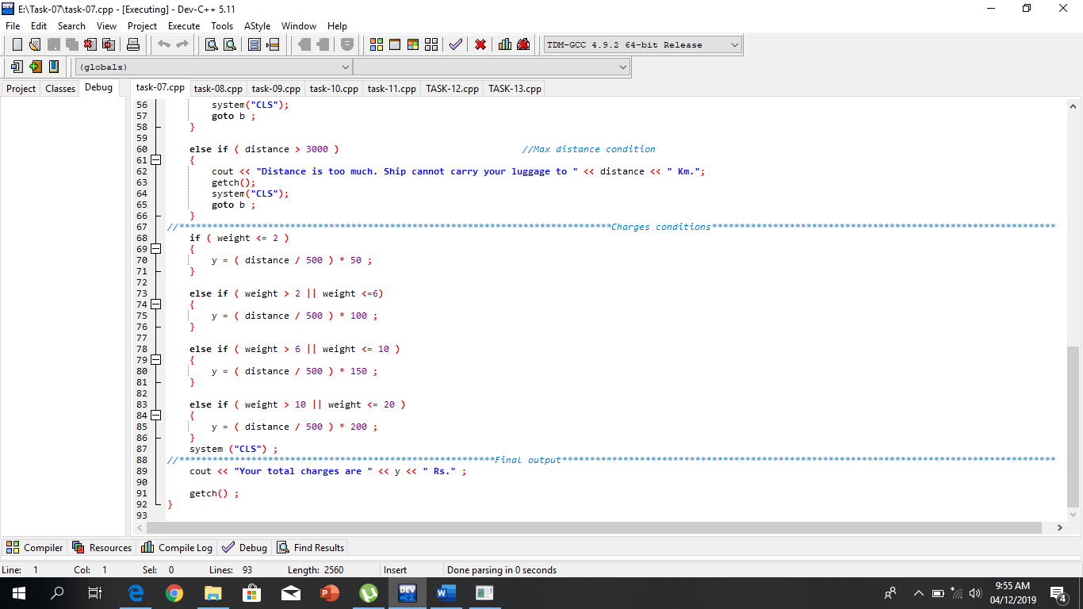

**OUTPUT:**

